CSE 499B

Project Report

**Farm-Ware**

Section 11

Team Name: Agronomists

Group Members

Tahmim Ali (ID - 1510444042)

Jubayer Uddin Shamim (ID - 1511989642)

Md. Fahad Hasan Chowdhury (ID - 1610331042)

Md. Shohaib Islam (ID - 1611237042)

Submission Date:

02.01.20



Department of Electrical and Computer Engineering

North South University

Fall 2019

*Dedicated to*

*Our Beloved Dihan Sir*

**Acknowledgement**

We would like to Thanks our faculty, **Dihan Md. Nuruddin Hasan** sir to give us this opportunity to do this project on **“Farm-Ware”**. It was really a good opportunity for us because we got to learn so many new things which will be very useful for us. Also we would like to thank our friends who helped us to know more about this project and our group members, who were very dedicated and active.

**Table of Contents**

**1. Introduction …………………………....…………………………………………………5**

**2. Problem Statement……………………………………………………………………….5**

**3. Proposed Solution ………………………………………………………………………....6**

**4. Related Work ………………………………………………………………………….......7**

**5. Technical Approach……………………………………………………………………...10**

**6. Description of the Project output and discussion ……………………………………...24**

**7. Lesson learnt ………………………………………………………………………...……….24**

**8. Timeline ………………………………………………………………………………...……25**

**9. Team Dynamics………………………………………………...26**

**10. Conclusions …………………………………………………………………………............27**

**11. Reference …………………………………………………………………………………...27**

**Introduction**

We have done the project farm-ware to make it easy for the people to get enough information about the temperature, humidity, soil moisture etc. of a particular area.

Bangladesh is an agricultural country. But maximum number of our farmers are uneducated.

So they can’t access the facility of the digital services related to agriculture using smart devices. Project Farm-Ware is based on this context to provide information collected by Hardware tools and served by easy interface presenting the information only. Farm ware is also included with website and smartphone application to spread the collected information.

The hardware part is going to build by using micro controller and sensors. The information will be about the temperature, soil moisture, humidity, water flow and water level, pesticides, plant growth etc. The information will be presented on spot by the device. Information will also be stored in the cloud. The information can be accessed through our app easily and simply. We have also implemented machine learning using our sensors data. Which will determine the growth rate of the plants. Most of the people in this country is depended on agriculture and that is why keeping this in mind we developed this project to make farming easier for the people. With the growing adoption of the Internet of Things (IoT), connected devices have penetrated every aspect of our life, from health and fitness, home automation, automotive and logistics, to smart cities and industrial IoT. Thus, it is only logical that IoT, connected devices, and automation would find its application in agriculture and, as such, tremendously improve many facets of the farming practice. The agriculture industry could be further developed by employing new technologies, in particular, the Internet of Things (IoT). Farming has seen a number of technological transformations in the last decades, becoming more industrialized and technology-driven. By using various smart agriculture gadgets, farmers have gained better control over the process of raising livestock and growing crops, making it more predictable and efficient.

**Problem Statement**

Farming is not an easy job there is a lot to handle and also farmers need to know so many information like what is good for their plant and what is not also they should know about the atmosphere. To provide efficient decision support system using wireless sensor network which handle different activities of farm and gives useful information related to farm field to farmer. As our country is developing, our farming system should also develop. Many farmers lack the knowledge of smart farming and also how to apply technology for their benefit.

**Proposed Solution**

Our solution in this situation is creating Farm-Ware. It will save time and toil both. Also it is a low cost project so that the farmers can implement it on their land and can get the information easily and quickly. Our solution has some attractive features like:

1. Low cost to implement the whole system.
2. Simple design.
3. Easy to implement.
4. Easy to install the app.
5. Easy to use.
6. Data is stored directly.
7. Stored data can be access easily.

In its simple form, our system is consists of some sensors to get the data’s from the atmosphere. The whole system will look like this:

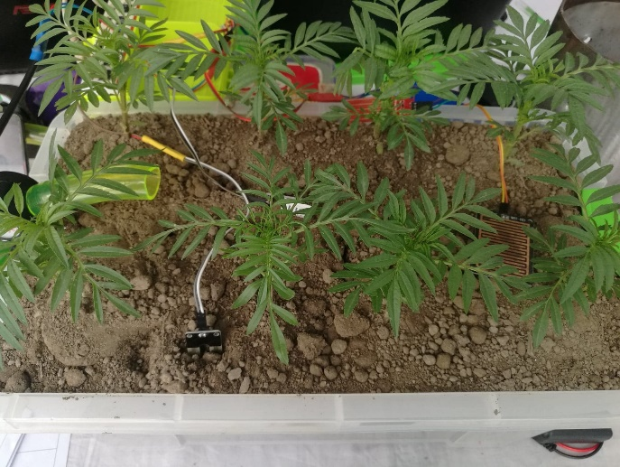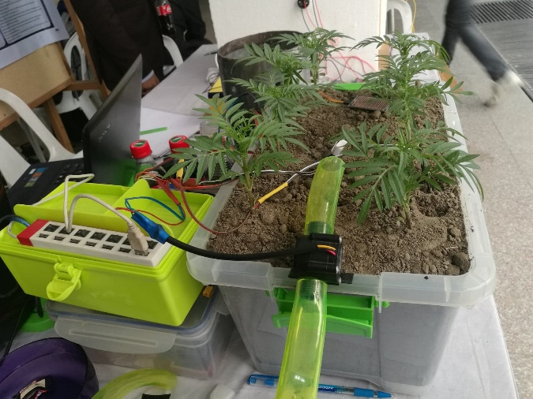

The sensors will be placed in the particular area like this and also we will implement a camera which will take pictures of the plants to show the growth rate of the plants. The whole thing will be connected with the app, so that all the data’s will be visible on the app.

This system will create a great impact on uses of daily life of the farmers as it will reduce their toil and time. Also it will be very useful for a large farming area.

    
Higher productivity Improved quality data capture Lower cost

Our system will work like the following work flow:

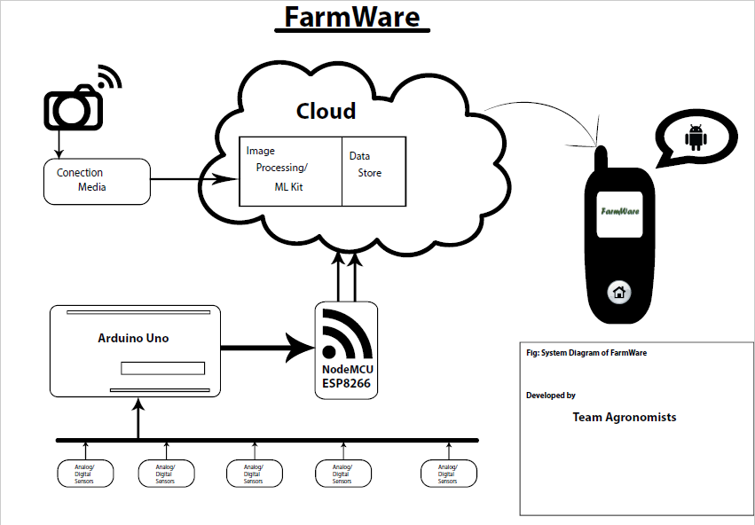

Fig. : System diagram

**Related work**

Smart farming is now a days most popular among the farmers of the developed country. Some of the related works of smart farming based on IoT are as follows:

**a. Precision Farming**

Precision farming is a process or a practice that makes the farming procedure more accurate and controlled for raising livestock and growing of crops. The use of IT and items like sensors, autonomous vehicles, automated hardware, control systems, robotics, etc in this approach are key components.

Precision agriculture in the recent years has become one of the most famous applications of IoT in agricultural sector and a vast number of organizations have started using this technique around the world. The products and services offered by IoT systems include soil moisture probes, VRI optimization, and virtual optimizer PRO, and so on. VRI (Variable Rate Irrigation) optimization is a process that maximizes the profitability on irrigated crop fields with soil variability, thereby improving yields and increasing water use efficiency.

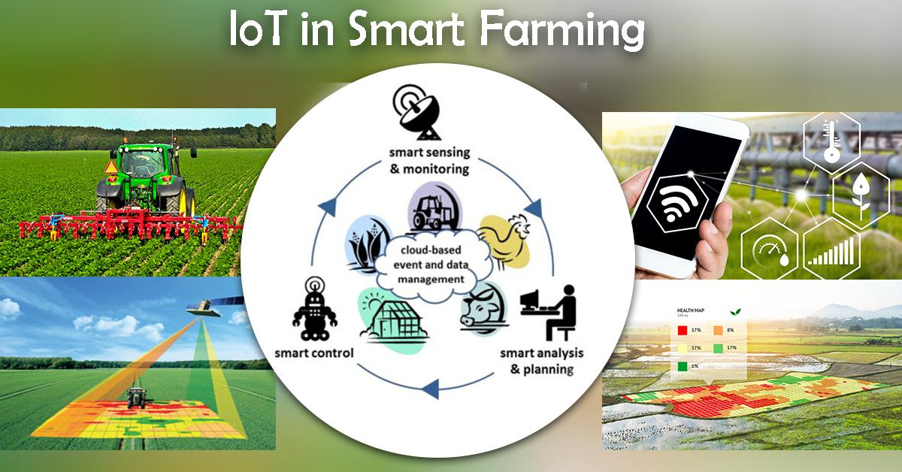

### b. Agriculture Drones

Agricultural drones are a very good example of IoT applications in Agriculture. Agriculture industries today, have become one of the major industries where drones can incorporate. Two types of drones, that is, ground-based and aerial-based drones are being incorporated in agriculture in many ways such as, for crop health assessment, irrigation, planting, and soil & field analysis. The benefits that the usage of drones brings to the table include, ease of use, time-saving, crop health imaging, integrated GIS mapping, and the ability to increase yields. The drone technology will give a high-tech makeover to the agriculture industry by making use of strategy and planning based on real-time data collection and processing. The farmers through drones can enter the details of what field they want to survey. Select an altitude or ground resolution from which they what data of the fields. From the data collected by the drone, useful insights can be drawn on various factors such as plant counting and yield prediction, plant health indices, plant height measurement, canopy cover mapping, nitrogen content in wheat, drainage mapping, and so on. The drone collects data and images that are thermal, multispectral and visual during the flight and then lands at the same location it took off initially.

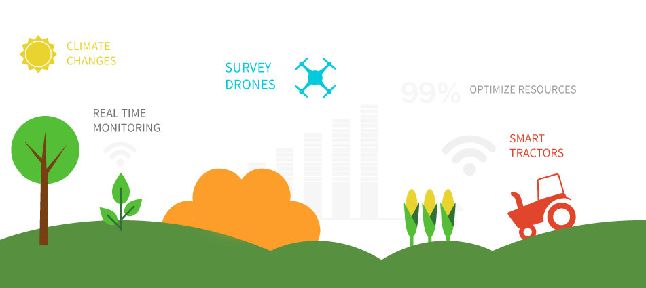

### c. Livestock Monitoring

IoT applications help farmers to collect data regarding the location, well-being, and health of their cattle. This information helps them in identifying the condition of their livestock. Such as, finding animals that are sick so, that they can separate from the herd, preventing the spread of the disease to the entire cattle. The feasibility of ranchers to locate their cattle with the help of IoT based sensors helps in bringing down labor costs by a substantial amount. One example of an IoT system in use by a company is JMB North America. Which is an organization that provides cow monitoring solutions to cattle producers? Out of the many solutions provided, one of the solutions is to help the cattle owners observe their cows that are pregnant and about to give birth. From them, a battery that is sensor powered is expelled when its water breaks. An information is then sent to the herd manager or the rancher. The sensor thus enables farmers will more focus.

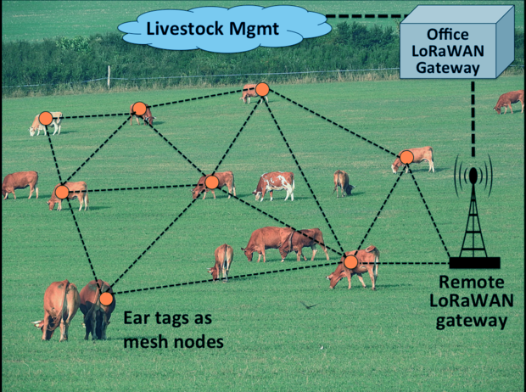

**Technical approach**

The equipment’s that we used to develop our whole system are given below:

1. Arduino Uno board

2. Temperature sensor

3. Humidity sensor

4. Water level sensor

5. Water flow sensor

6. Raindrop sensor

7. Soil moisture

8. Bread-Board

9. NodeMCU ESP8266 Module

10. Wires

11. Android app studio for the app

12. Firebase for storing data

13. Arduino IDE

14. Codelab

15. Python

Hardware Part:

**Temperature and Humidity sensors:**

We have used Arduino for our project and also done the coding that will detect the temperature and humidity of the atmosphere using DHT22 temperature and humidity sensor.

**Code:**

#include "DHT.h" //include the DHT library

#include <stdio.h>

#include <LiquidCrystal.h> //include the LiquidCrystal library

#define DHTPin 2 //define DHT pin

LiquidCrystal lcd(1, 3, 4, 5, 6, 7); //define LCD pins (RS, E, D4, D5, D6, D7)

DHT dht; void

setup() {

dht.setup(DHTPin);

Serial.begin(9600); //initializes the LCD and specifies the dimensions

}

void loop() {

float temp = dht.getTemperature(); float

humi = dht.getHumidity();

Serial.println(dht.getTemperature());

Serial.println(dht.getHumidity());

delay(2000);

}

**Arduino IDE snap:**



Serial Monitor snap:



**Circuit:**



**Water Level Sensor:**

Water level sensor is used to measure the level of water of a particular area.

**Code:**

void setup() {

// initialize serial communication at 9600 bits per second:

Serial.begin(9600);

}

// the loop routine runs over and over again forever:

void loop() {

// read the input on analog pin 1: int sensorValue

= analogRead(A1);

// print out the value you read:

Serial.print("Water Level:"); Serial.println(sensorValue); delay(1000);

// delay in between reads for stability

}

**Arduino IDE snap:**



**Serial Monitor Snap:**

**Circuit:**



**Water flow sensor:**

We have used Arduino for our project and also done the coding that will detect the irrigation using Water Flow Sensor.

**Code:**

void setup() {

// initialize serial communication at 9600 bits per second:

Serial.begin(9600);

}

// the loop routine runs over and over again forever:

void loop() {

// read the input on analog pin 0: int sensorValue =

analogRead(A0); // print out the value you read:

Serial.println(sensorValue); delay(100); // delay

in between reads for stability

}

**Arduino IDE snap:**



**Serial Monitor snap:**



**Circuit:**



**Raindrop sensor:**

It will detect the rain drop using the sensor DHK MH-RD Raindrop Sensor.

**Code:**

void setup() {

// initialize serial communication at 9600 bits per second:

Serial.begin(9600);

}

// the loop routine runs over and over again forever:

void loop() {

// read the input on analog pin 0:

int sensorValue = analogRead(A0); //

print out the value you read:

Serial.print("Raining Level:");

Serial.println(sensorValue); delay(1000); // delay

in between reads for stability

}

**Arduino IDE snap:**



**Serial monitor snap:**



**Circuit:**



**Below is the picture of the whole hardware part:**



**NodeMCU ESP8266 Code:**



**Data Stored in firebase:**



**Software Part:**

Our software part is done using android studio, firebase and google colab. The android app layout and google colab codes are:

**ML Implementation:**

We have introduced machine learning to our project to detect the growth of the plants. We have used our own dataset for ML part. We have taken Merrie Gold plant of different size as dataset to train our hardware using machine learning process.

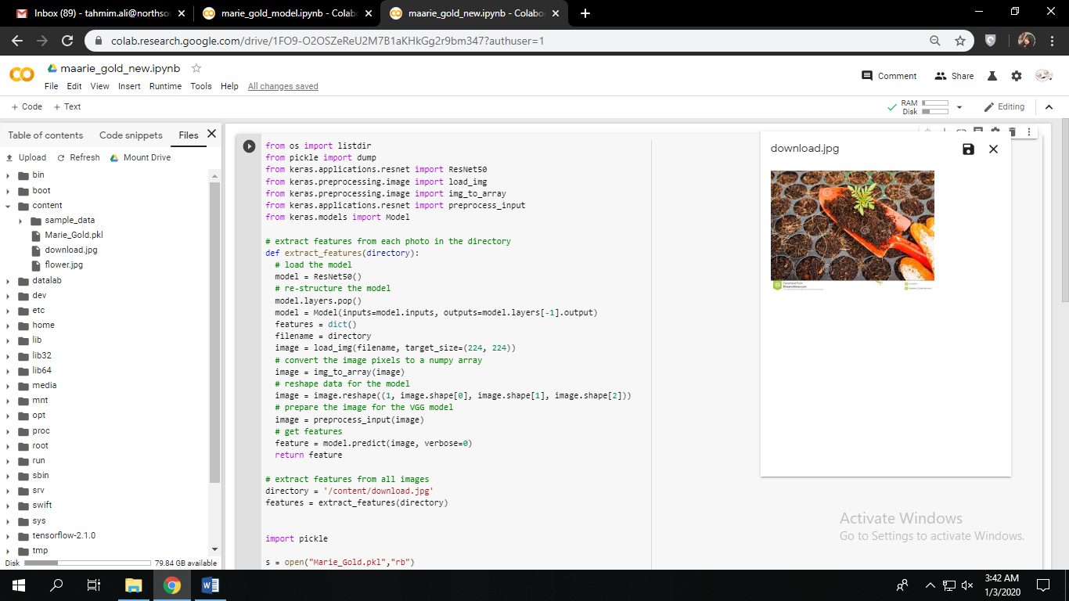For ML we have chosen the Google Colab IDE and Python programming language. Some snapshot of our work has been shared here:

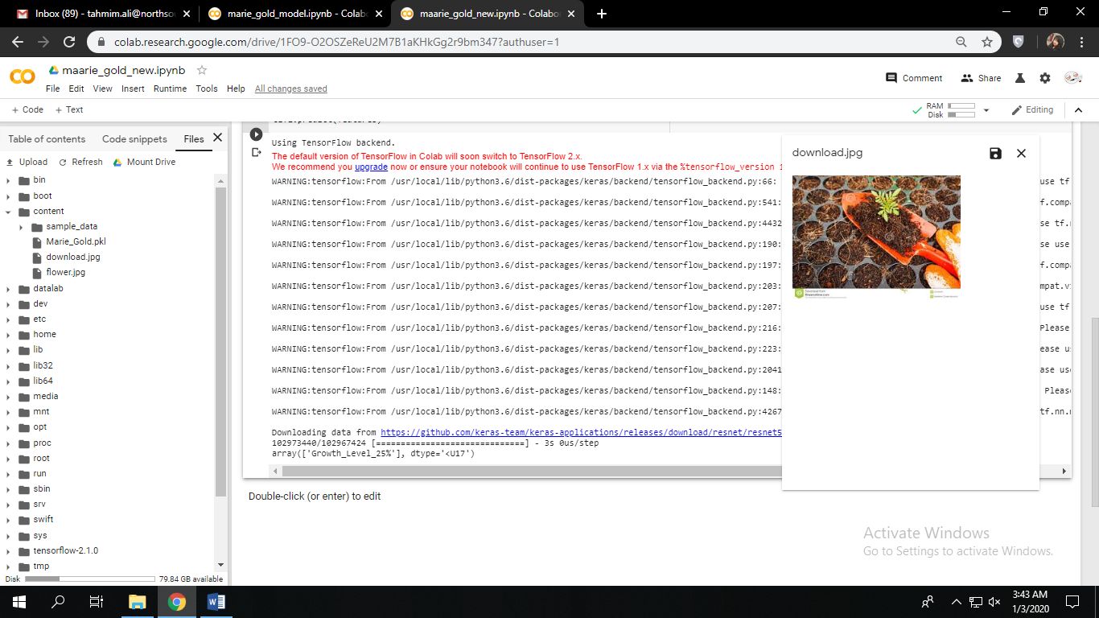

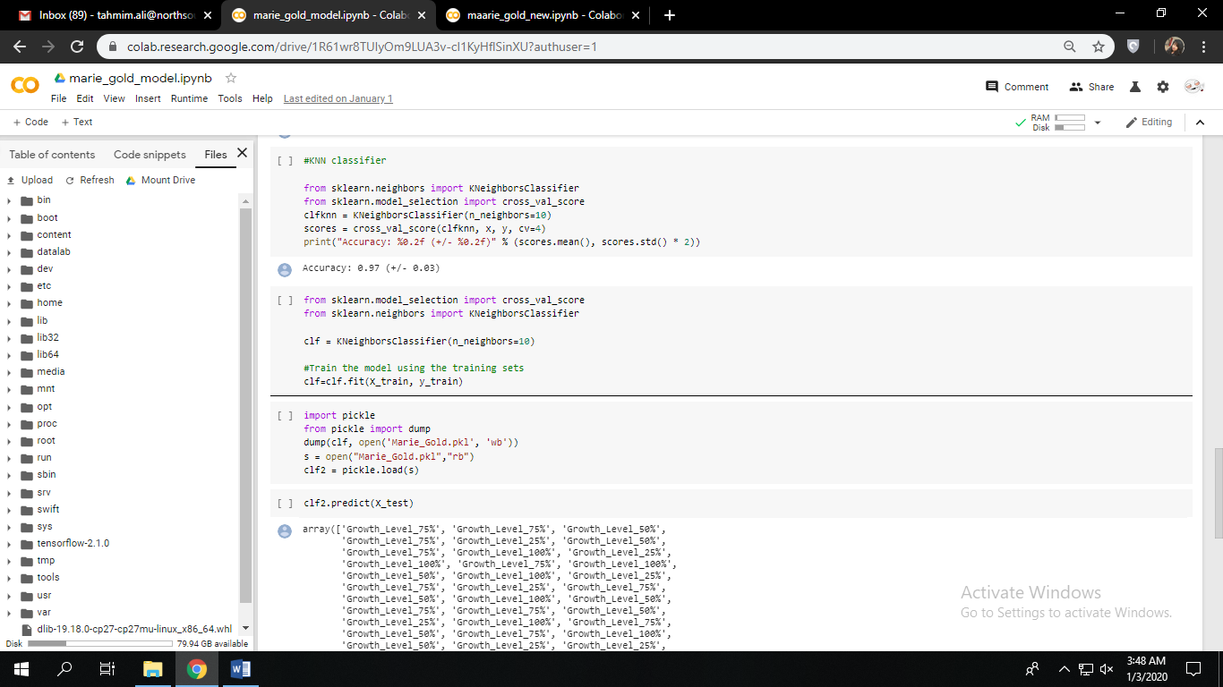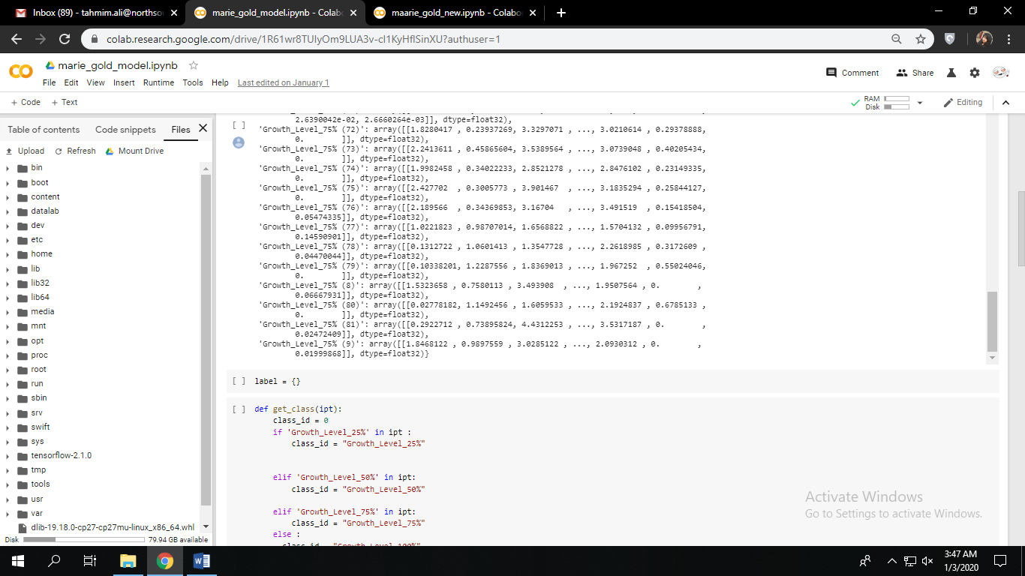Here we have used 60% of our data for training and remaining for testing in a rotational way and several times. This training gives us much more reliable output. We use KNN classifier and got **97%** accuracy of our output.

**Android App:**

We have made an android app for showing our hardware data, status, map location, weather etc. Our goal for developing this app is to remote control of the hardware and have an analytical prediction for certain scenario.

We have used android studio to develop this app. Some snapshot of our work has been shared here:

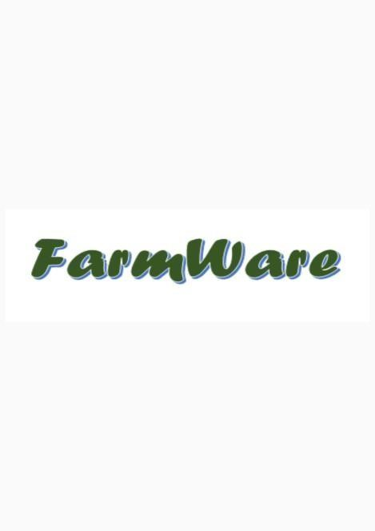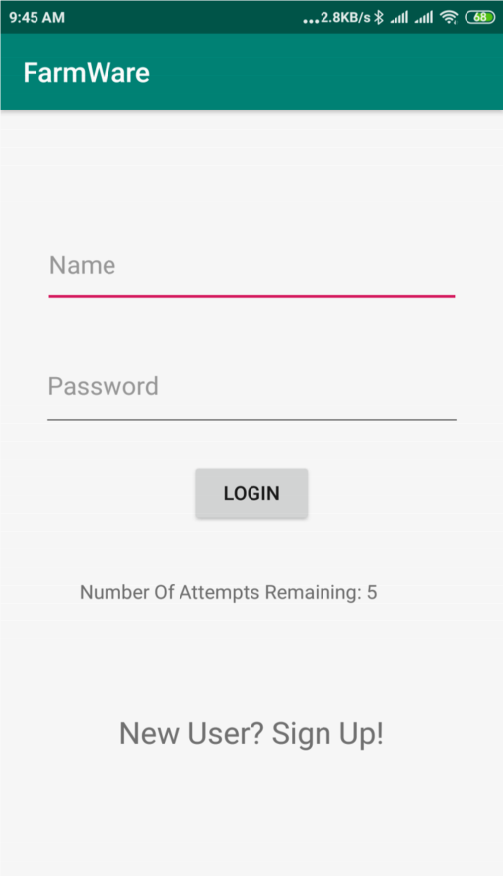

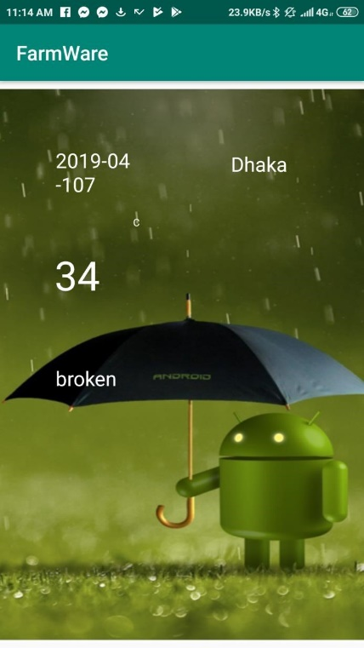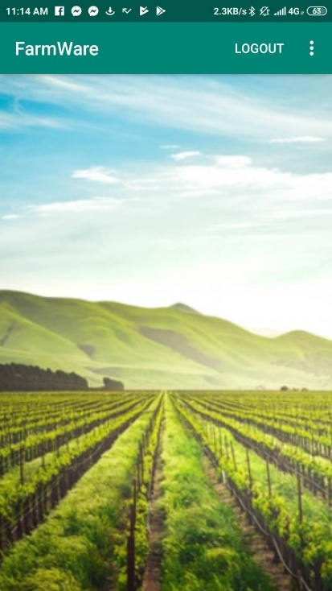

**Project Description and Discussion**

At first we implemented the sensors to take the values of temperature, soil moisture, humidity, raindrop, water flow and water level. Then using NodeMCU ESP8266 Module we sent the data’s to the cloud that is the data’s were stored in the firebase. Also we developed an app so that it will access the stored data’s of the firebase and will show in it. Then we implemented Machine learning to detect the plant growth rate, the ML codes were done ion google colab using python. We have trained more than 300 dataset for our ML, using our dataset we designed this model in such a way that if we take a picture of any plant and upload it then the system will give us the growth rate of that plant. As we did not had enough time and we were newbie to machine learning we did not move further with this project but we have a plan to develop our system more further such that it will take auto snaps of plants and will notify automatically about the growth rate of the plants.

**Lesson Learnt**

While starting this project we thought that it would be easy to complete this project but then we realized it is really tough. So, we have learnt a lot of lessons while solving this problem.

* We learnt python to code for ML.
* We knew the basics of android development but for this problem we learnt many more things about android development.
* We learnt how to implement machine learning.

**Timeline**

|  |  |  |  |  |  |  |  |  |  |  |  |  |  |
| --- | --- | --- | --- | --- | --- | --- | --- | --- | --- | --- | --- | --- | --- |
|  |  | WEEK | | | | | | | | | | |  |
| SL | Deliverable | 4 | | 8 | | 12 | | 16 | | 20 | | | Man-Week |
| 1 | Front end development |  | | | | |  | | | | | | 10 |
| 2 | Hardware implementation |  |  | | | | |  | | | | | 10 |
| 3 | Database management |  | | |  | | |  | | | | | 6 |
| 4 | Testing & debugging |  | | | |  | | | |  | | | 4 |
| 5 | Machine learning |  | | | | | | |  | |  | | 4 |
| 6 | Deployment and final release |  | | | | | | | |  | |  | 4 |
| **Total duration** | | | | | | | | | | | | | 18 |

**Team Dynamics**

|  |  |  |  |  |
| --- | --- | --- | --- | --- |
|  | Hardware Part | Description | Time | Contribution |
| 1 | Temperature sensor | will determine the temp. of an area | week-1 | Shohaib Islam |
| 3 | Humidity sensor | will determine the humidity of the air | week-2 | Shohaib Islam |
| 4 | Water level | it will determine the water level | week-3 | Tahmim |
| 5 | Water flow | determine how much water will flow | week-4 | Tahmim |
| 6 | Soil moisture | determine the moisture of the soil | week-5 | Fahad Hassan |
| 7 | Rain Drop | determine the amount of rain | week-6 | Jubayer |
|  | Software Part |  |  |  |
| 8 | Starting page (Android app) | the opening page of the app | week-7 | Jubayer |
| 9 | Login page | login will be required for a user profile | week-7 | Fahad Hasan |
| 10 | Registration page | to register a new profile | week-7 | Tahmim |
| 11 | Main page | it will contain the info's | week-8 | Jubayer |
| 12 | Google Location | it will take the location | week-9 | Jubayer |
| 13 | Google API | to access the google map | week-9 | Tahmim |
| 14 | Database | will store the values from sensors | week10-11 | Shohaib Islam |
| 15 | Dataset |  | week-12 | Jubayer, Shohaib |
| 16 | ML Implementation | Will determine plant growth rate | week 13-17 | Tahmim, Fahad Hasan,  Shohaib |
|  | Final Demo |  | week 18 |  |

**Conclusion**

Our device and the app is very useful, especially for the farmers. Which helps them to get their needed data and information quickly. It will help them to ease their life and do their agriculture work perfectly as they are getting all the information about the weather and the soil. We will further develop our app and the device in such a way that the farming equipment’s can also be controlled from anywhere also we are planning to implement a camera on the spot which will take few snaps automatically and will detect the growth rate of the plants on a weekly basis. We are working on our project to develop it to that level and make it very useful.

**References**

<https://data-flair.training/blogs/iot-applications-in-agriculture/>

<https://dzone.com/articles/iot-in-agriculture-five-technology-uses-for-smart>

<https://searchenterpriseai.techtarget.com/definition/machine-learning-ML>

<https://machinelearningmastery.com/machine-learning-in-python-step-by-step/>

<https://reliefweb.int/report/bangladesh/climate-smart-agriculture-bangladesh>